Documentation

*Automation with Selenium WebDriver & JAVA & JUnit & Maven & IntelliJ*



[vanja.franjic@comtradesoftware.com](mailto:vanja.franjic@comtradesoftware.com)

**Why I choose what I did ?**

I choose to work on this test using Junit, Maven and Cucumber because I worked within this envirnment during my pool learning period. I picked Page Object design pattern because it gives me flexibility over my tests allowing me to manipulate page elements without digging around in the HTML. I have also used PageFactory class in an extension to the Page Object design pattern so that i could initialize the elements of the Page Object. I used it mainly because i didn't want to use code duplication – 'FindElement'. I have also created User Account manually, do that user wouldn't depend on being registered.

**Hint:** Test will run in Google Chrome browser (but it can be run also on Firefox and IE).

**Prerequisites:**

Web Automation Framework: Selenium Webdriver

Testing BDD Framework: Cucumber

Development Kit: JAVA JDK

Java Test Runner: JUnit

IDE: IntelliJ (I prefer IntelliJ) also you can go with Eclipse

Build System: Maven

**How to Run Tests ?**

1. Open up InelliJ Idea
2. Go to File > Open > Open File or Project
3. Select folder from the Tree view of a directory: C:\Users\user\Desktop\ryanairtest-master
4. Wait for project to load
5. Then, you should click “Enable Auto-Import”. When you change your pom.xml maven automatically imports the required files according to your changes.

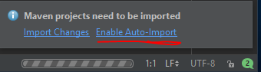

1. Again wait for Auto-Import
2. Run Test: Click Run icon on upper menu or you can just press Ctrl+Shift+F10

* Zoom for detailed view

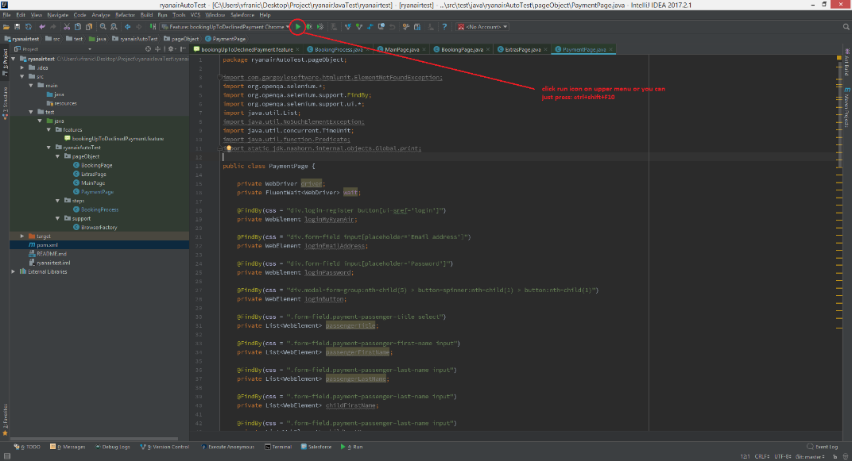

* The Test Run html file is located inside project folder where you can find report from the test result.